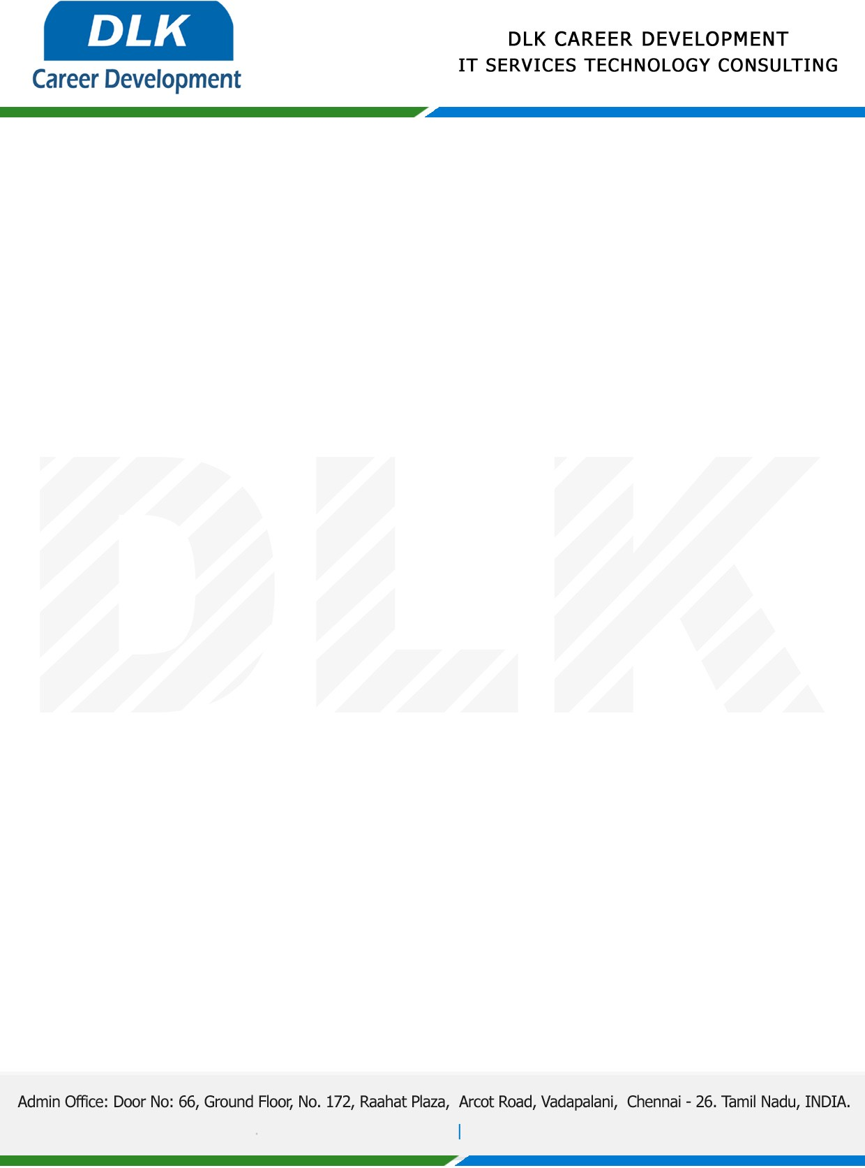

Date: 22/May/ 2023

**SUBJECT: INTERNSHIP COMPLETION CERTIFICATE**

This is to certify that **MR CHAKKARAVARTHY J (REG NO: 2127200701303)** of **BE (Electronics and Communication Engineering)** third year student at **Sri Venkateswara College of Engineering, Chennai** has Successfully Completed the Internship Work under the domain of **“IOT “** in our organization during the Period **(20th April 2023** to **5th May 2023).**

We appreciate your interest in **DLK CAREER DEVELOPMENT**

“Best Wishes for Your Future Endeavors “

For **DLK CAREER DEVELOPMENT**

